SmartCare v0.3 - Domain Model Workbook
Week 6 student resource

Requirement-to-Concept Trace
Requirement | Concept | State/behaviour | Decision
FR-01: Patient Registration | Patient | Attributes: patient_id, name, DOB, phone, email, medical_notes. Behaviour: register(), validate_data() | Include
FR-02: Patient Search & Retrieval | Patient | Behaviour: search_by_name(), search_by_id() for quick lookup within 2 seconds | Include
FR-03: Appointment Booking | Appointment | Attributes: appointment_id, patient_id, practitioner_id, time, status. Behaviour: create() with conflict validation | Include
FR-04: Duplicate Prevention | Appointment | Behaviour: check_overlap(practitioner_id, time) prevents same practitioner overlapping times | Include
FR-05: Status Management | Appointment | Attributes: status (Pending/Confirmed/Completed/Cancelled), status_change_timestamp. Behaviour: change_status() | Include
FR-06: Practitioner Calendar | Practitioner | Behaviour: get_available_slots(date_range), get_booked_slots(), display 4-week window | Include
FR-07: Appointment Cancellation | Appointment | Attributes: cancellation_reason, cancellation_timestamp. Behaviour: cancel() records reason | Include
FR-08: Appointment Rescheduling | Appointment | Behaviour: reschedule(new_time) with conflict validation on new slot | Include
FR-09: Appointment History | AppointmentHistory | Attributes: history_id, appointment_id, immutable changes list. Behaviour: log_change(), get_full_history() | Include
FR-10: Operational Reporting | AppointmentReport | Behaviour: generate_utilization(), calculate_cancellation_rate(), get_booking_patterns() | Include
FR-11: Data Validation | Appointment/Patient | Behaviour: validate_data() checks non-empty name, valid email, valid time format, within clinic hours | Include
FR-12: Role-Based Access | User | Attributes: user_id, username, password_hash, role (Receptionist/Practitioner/Manager). Behaviour: authenticate(), check_permission() | Include
NFR-04: Performance | Appointment, Patient | Behaviour: search <2 sec, booking/cancellation <3 sec for 50K appointments | Include
NFR-05: Maintainability | All classes | Attribute: follow PEP 8, docstrings, 80% test coverage. Behaviour: modular design | Include

CRC Cards

Patient
Responsibilities | Collaborators
Store patient identity data - patient_id, name, DOB, phone, email, medical_notes | Appointment - Patient has many appointments over time
Generate/assign unique patient ID automatically on registration | User - Receptionist (user) creates patient records
Validate patient data - Ensure non-empty name, valid email format, valid DOB (not future) | SecurityManager - Encrypt phone, email, DOB before storage
Enable patient lookup - Search by full name or patient ID with 2-second response (FR-02, NFR-04) | AppointmentHistory - Track patient's appointment change history
Maintain patient profile immutability - Once created, patient demographics don't change (or change is logged) | NONE

Practitioner
Responsibilities | Collaborators
Store practitioner identity - practitioner_id, name, specialty | Appointment - Practitioner has many appointments (can see multiple patients/day)
Manage working hours - Define standard clinic hours (8 AM-6 PM Mon-Fri) per practitioner | AppointmentReport - Report generates utilization % (booked slots / available slots)
Define blocked time - Add lunch breaks, admin time, days off to block practitioner from bookings | User - Practitioner (user) views own schedule (FR-12)
Display available time slots - Return free slots for 4-week window for booking interface (FR-06) | SecurityManager - Audit log practitioner actions (schedule changes, availability updates)
Check availability - Query whether practitioner is free at specific time (used by Appointment.check_overlap()) | NONE

Appointment
Responsibilities | Collaborators
Store appointment data - appointment_id, patient_id, practitioner_id, time, status, duration (30 min fixed) | Patient - Each appointment belongs to exactly patient
Implement business rule BR-1 - Prevent overlapping time slots for same practitioner on same day (FR-04) | Practitioner - Each appointment is with exactly 1 practitioner
Call check_overlap() at booking time - Query Practitioner.check_availability() before creating appointment | AppointmentHistory - Log every change (creation, status, cancellation, reschedule) with timestamp
Manage appointment lifecycle - Transition status: Pending→Confirmed→Completed or Cancelled (FR-05, BR-2) | User - Receptionist/Practitioner perform actions; audit logged
Record cancellation details - Store cancellation_reason and cancellation_timestamp (FR-07) | SecurityManager - Audit log all appointment actions

Optional class
+) User:
Responsibilities | Collaborators
Store authentication credentials (user_id, username, password_hash - never plain text) | SecurityManager (password verification, role permission checks)
Store role information (Receptionist/Practitioner/Manager) for access control (FR-12) | Appointment (receptionist creates/cancels appointments)
Authenticate user on login (FR-12, NFR-06) | AppointmentHistory (user_id recorded with every action)
Check role-based permissions for actions (only Receptionist can book, Manager can view reports, Practitioner can view own schedule) (FR-12) | AppointmentReport (only Manager role accesses reports)
tore authentication credentials (user_id, username, password_hash - never plain text) | SecurityManager (password verification, role permission checks)

+) SecurityManager:
Responsibilities | Collaborators
Encrypt sensitive data at rest - Apply AES-256 encryption to patient phone, email, DOB in database (NFR-06) | Patient - Encrypt patient phone/email/DOB
Encrypt data in transit - Enforce TLS 1.3+ for all client-server communication (NFR-06) | Appointment - Encrypt appointment notes if any
Manage encryption keys - Store encryption keys in secure key vault (NOT in code or config files) (NFR-06) | User - Protect user password hashes (already hashed, but stored securely)
Authenticate users - Verify username/password at login time; compare hashed password (FR-12, NFR-06) | AppointmentHistory - Protect history records containing sensitive data
Audit log all actions - Log timestamp, username, action type, affected data for every system action (NFR-06) | NONE
Enforce password requirements - Validate passwords meet minimum complexity (8+ chars, upper, lower, digit, symbol) (NFR-06) | NONE

+) AppointmentHistory:
Responsibilities | Collaborators
Log all appointment changes - Track creation, status transitions, cancellations, rescheduling with immutable records | Appointment - One history log per appointment (1:1 relationship)
Record timestamp and user - Store WHEN change occurred and WHO made it (audit trail for compliance, NFR-06) | User - History records user_id of person who performed action
Store change detail - Log old state and new state (e.g., "status changed from Pending to Confirmed") | SecurityManager - History records are encrypted for sensitive details
Enforce immutability - Once logged, history entries cannot be modified or deleted (FR-09) | AppointmentReport - Historical data used for trend analysis and reporting
Support audit queries - Enable "show full history of this appointment" for compliance/disputes | NONE

UML Class Diagram
- Insert/draw UML here. Include defensible relationships and multiplicities.
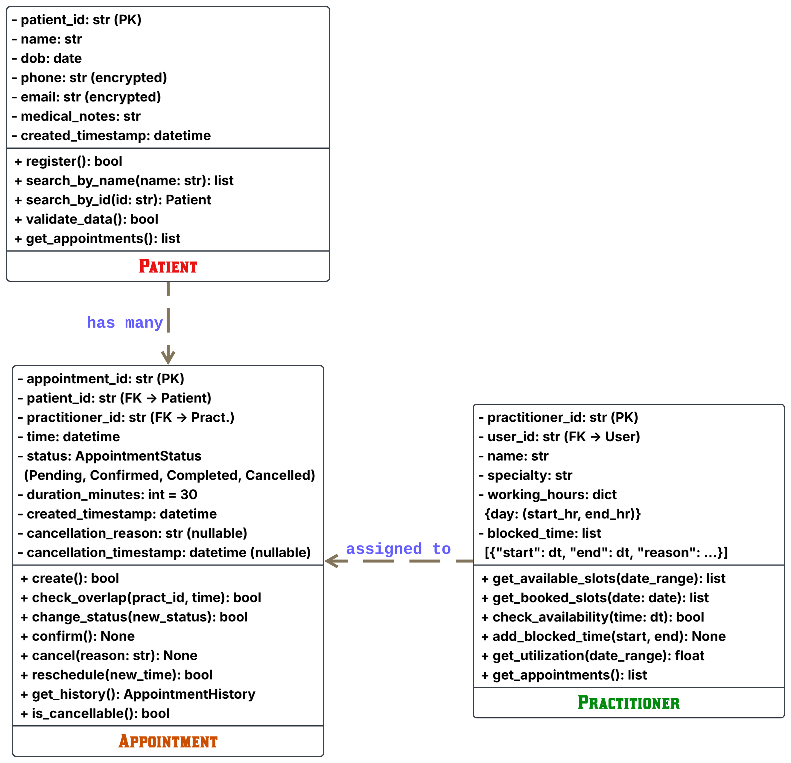
The Patient-to-Appointment relationship uses a 1 to 0..* multiplicity. A patient can exist without bookings or accumulate many over time, but every appointment must be tied to exactly one patient_id to prevent orphaned records.
The Practitioner-to-Appointment relationship also follows a 1 to 0..* multiplicity. A practitioner may have zero bookings during leave or many across active hours, while each appointment requires one assigned practitioner_id to enable overlap validation.
Using Appointment as an intermediary entity cleanly isolates transactional state—such as status, duration, and cancellation details. This design avoids complex many-to-many coupling while streamlining availability checks and audit logging.

Design Rationale
- Explain class selection, responsibility allocation and key relationships.
Class | Requirement Evidence | Why Essential
Patient | FR-01 (registration), FR-02 (search) | Represents clinic patient. Enables appointment linkage and patient lookup - core clinic operation.
Practitioner | FR-03 (appointment with), FR-04 (conflict), FR-06 (calendar) | Represents clinic staff/resource. Owns scheduling and availability - central to overbooking prevention.
Appointment | FR-03→FR-09 (entire workflow) | Central entity binding Patient + Practitioner + Time. Implements booking logic, conflict detection, lifecycle management.
User | FR-12 (authentication, RBAC) | Guards access control. Every action audited to User. Essential for compliance and permissions.
AppointmentHistory | FR-09 (immutable history), NFR-06 (audit logging) | Required by compliance requirements. Enables audit trail and prevents tampering with records.
AppointmentReport | FR-10 (operational reporting), FR-12 (manager role) | Manager stakeholder explicitly needs utilization/cancellation metrics. Separate class enables independent reporting logic.
SecurityManager | NFR-06 (encryption, TLS, key mgmt, audit) | Cross-cutting security concerns. Centralizes encryption, authentication, audit logging across system.

- Essential Connections & Quantity:
+) Patient 1:* Appointment*
- One patient can have multiple appointments over time (revisits clinic)
- Minimum: 0 (patient created but no appointments yet - OK)
- Maximum: unlimited (patient can visit many times)
- Evidence: FR-09 (appointment history implies multiple per patient), FR-10 (reporting per patient), clinic domain knowledge (patients revisit)
+) Practitioner 1: *Appointment*
- One practitioner can see multiple patients per day (clinic operations)
- Minimum: 0 (practitioner hired but no appointments scheduled)
- Evidence: FR-04 suggests that practitioners manage several appointments each day, while FR-06 indicates that the availability calendar displays numerous time slots.
+) User 1:*Practitioner* (every practitioner possesses a single user account for access)
- Relationship identified during design: Practitioner.user_id → User
- Evidence: FR-12 mandates authentication by practitioners; practitioners must log in to access their schedule.
+) Appointment: *Patient* (every appointment is assigned to one specific patient)
*Practitioner* (each appointment occurs with one specific practitioner)
- Evidence: FR-03 states "choosing a patient, choosing a practitioner" (singular), v0.2 scope: no multiple practitioners or group appointments.

AI Design Review Record

AI suggestion | Decision | Evidence | Reason | Model change
PatientManager | REJECT | Considered an architectural anti-pattern since the Patient class directly encapsulates its own operations, making an external manager redundant. | Anti-pattern | X
PractitionerManager | REJECT | Adds unnecessary indirection because Practitioner already cohesively handles both its profile data and availability logic. | Anti-pattern | X
AppointmentManager | MODIFY | Current v0.2 booking workflows are simple. AI noted that complex multi-step processes or notifications should be introduced. | Workflow orchestrator | v0.2
ClinicController | REJECT | Violates architectural layering principles by introducing application controller logic into the core domain model. | Layer violation | X
NotificationManager | REJECT | Out of scope for release v0.2; explicitly postponed to version 0.3+ during Stage 2 planning. | Out of scope | v0.3
ScheduleEngine | ACCEPT | Fixed 30-minute time slots keep v0.2 scheduling straightforward | Abstraction | v0.2

Rejected Suggestions: Four abstractions (PatientManager, PractitionerManager, ClinicController, and NotificationManager) were rejected due to architectural anti-patterns, layering violations, or being out of scope for the v0.2 release.
Accepted & Modified Changes: ScheduleEngine was accepted for v0.2 to handle fixed 30-minute slot abstractions, while AppointmentManager was modified to orchestrate simple booking workflows.
Core Architectural Rationale: Decisions prioritized direct domain class encapsulation (keeping logic inside Patient and Practitioner) and avoiding premature complexity prior to future versions like v0.3.

